**Home Page**

Map of the United States using the Google Maps API. User can zoom and look at where the different national parks are located. If the user hovers over the marker, the name of the national park is displayed.

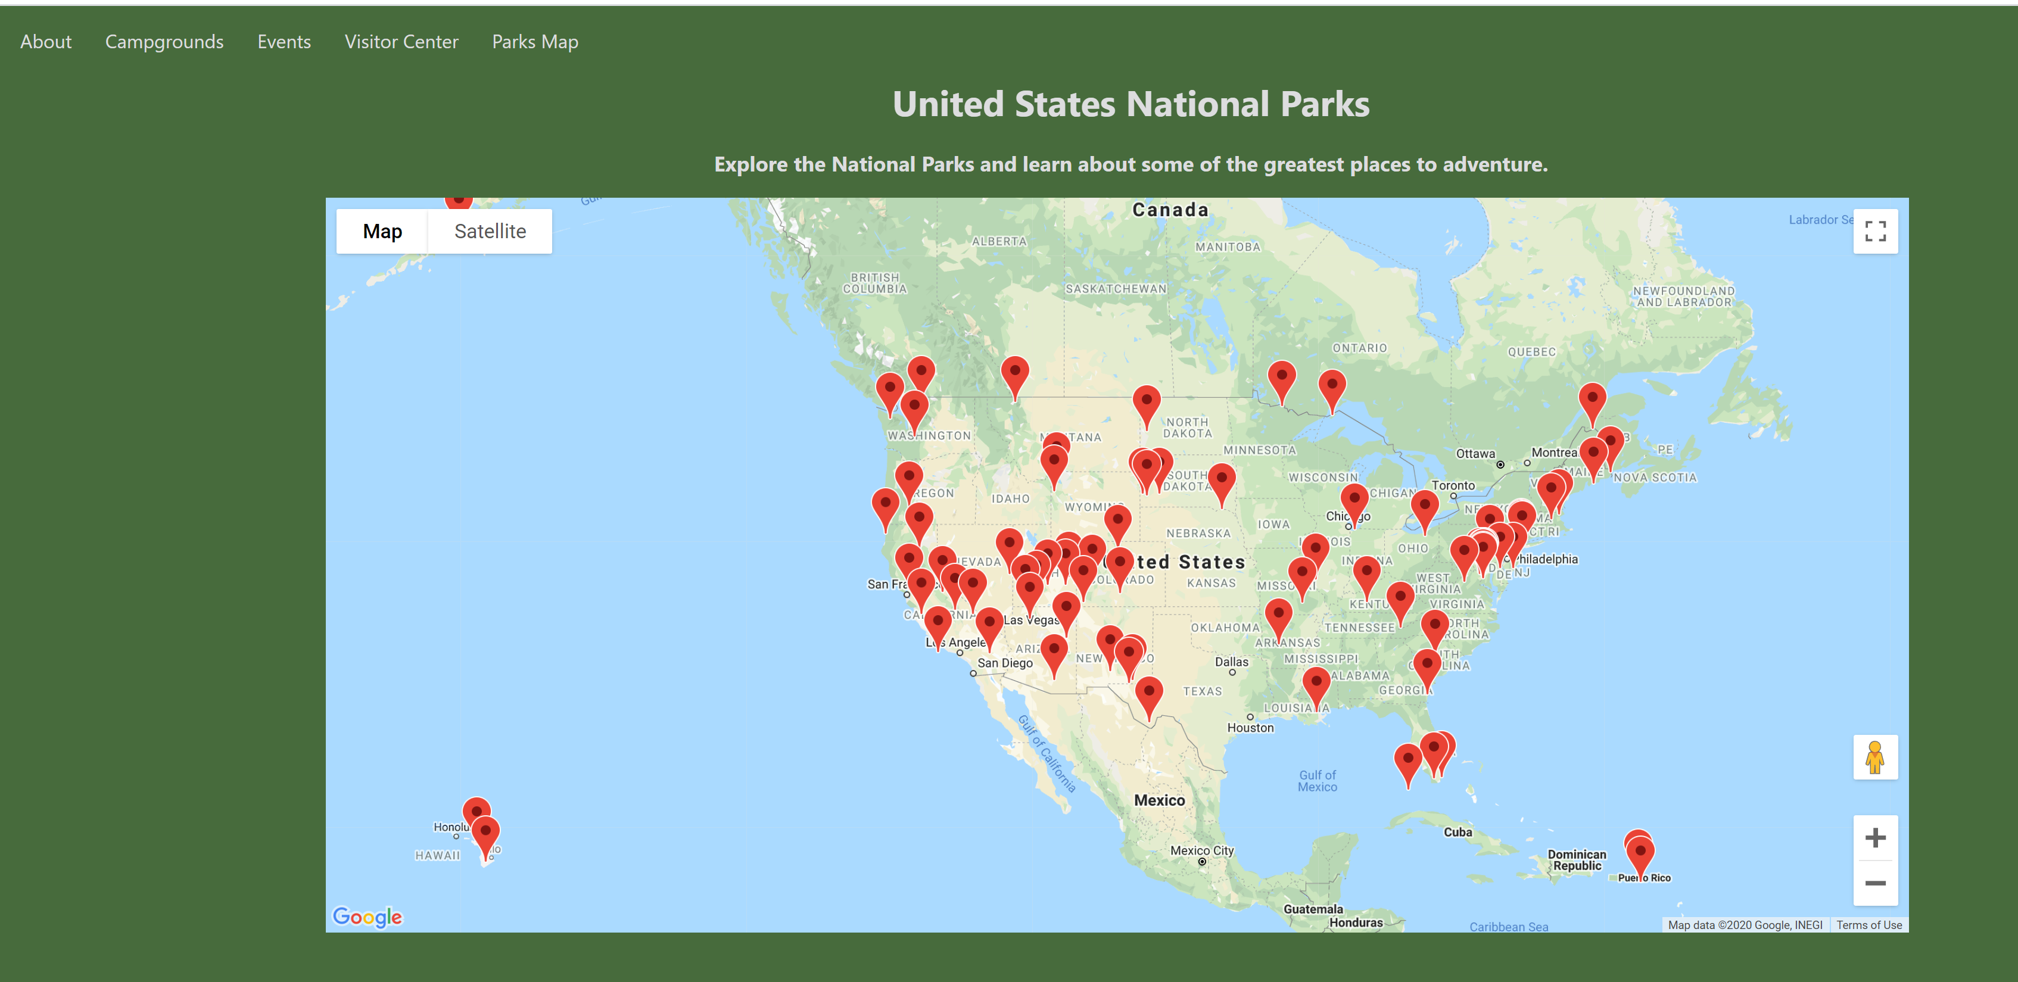

**About Page**

After the user selects the National Park they would like to explore it redirects you to the About Page where it gives your detailed information regarding that national park.

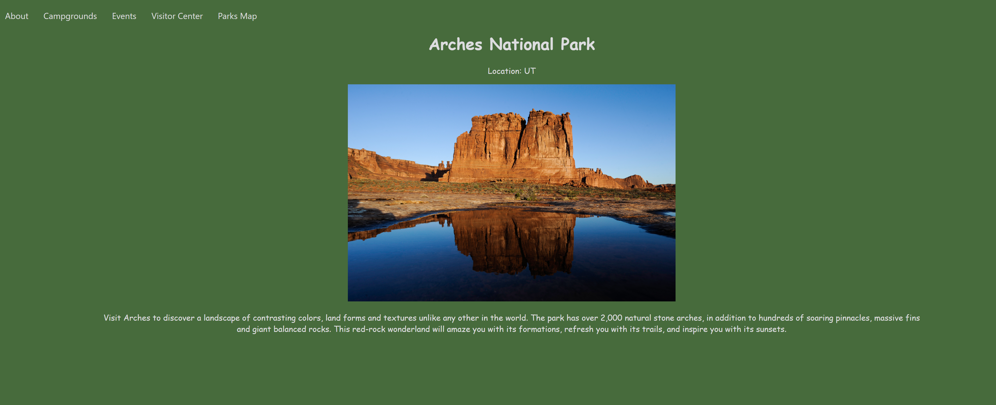

**Campground Page**

The user can select the campgrounds tab to learn about the Campgrounds that are located at that National Park.

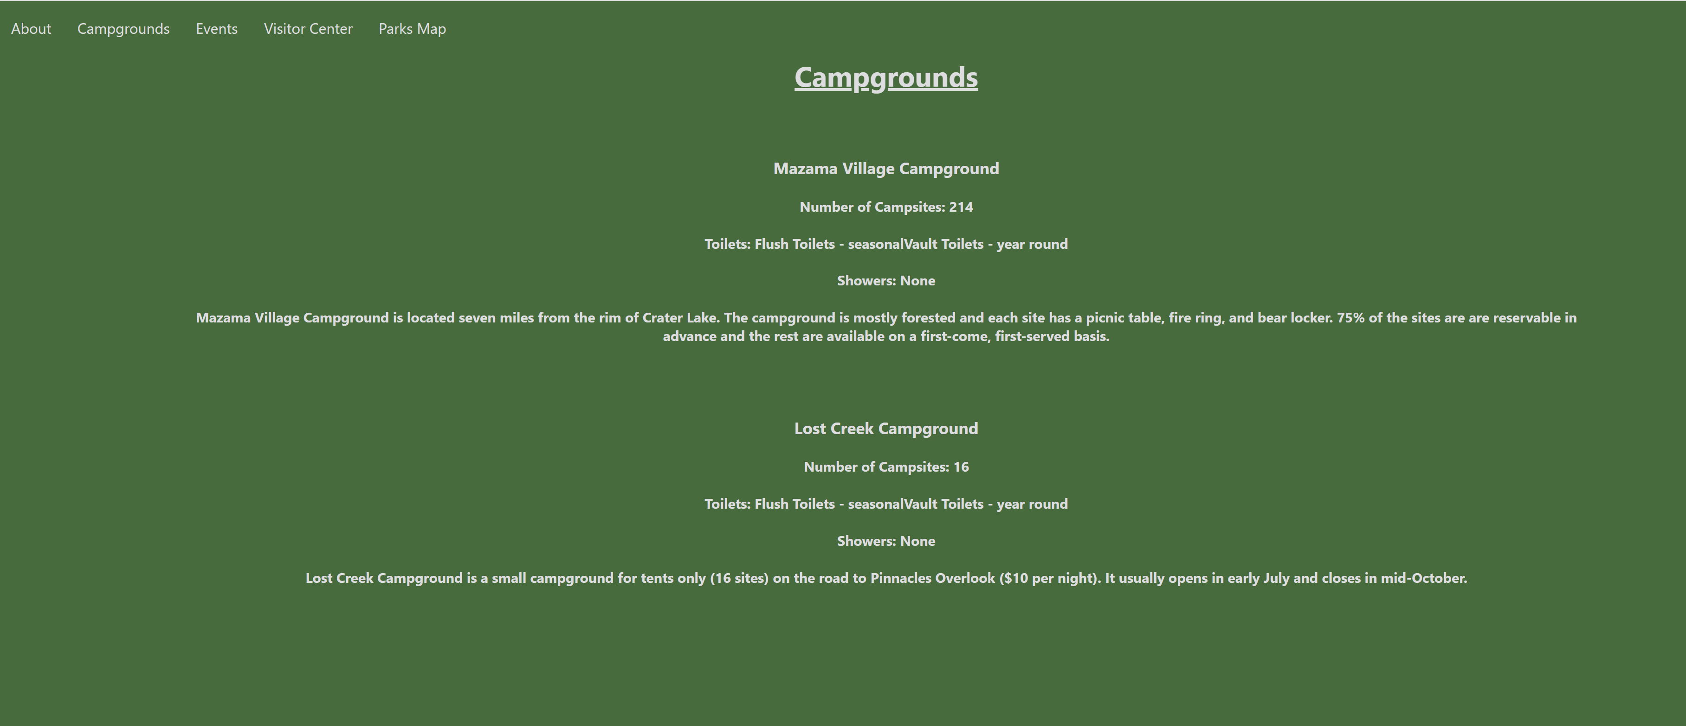

**Events Page**

The user can select the Events tab to learn about the Events that are located at that National Park.

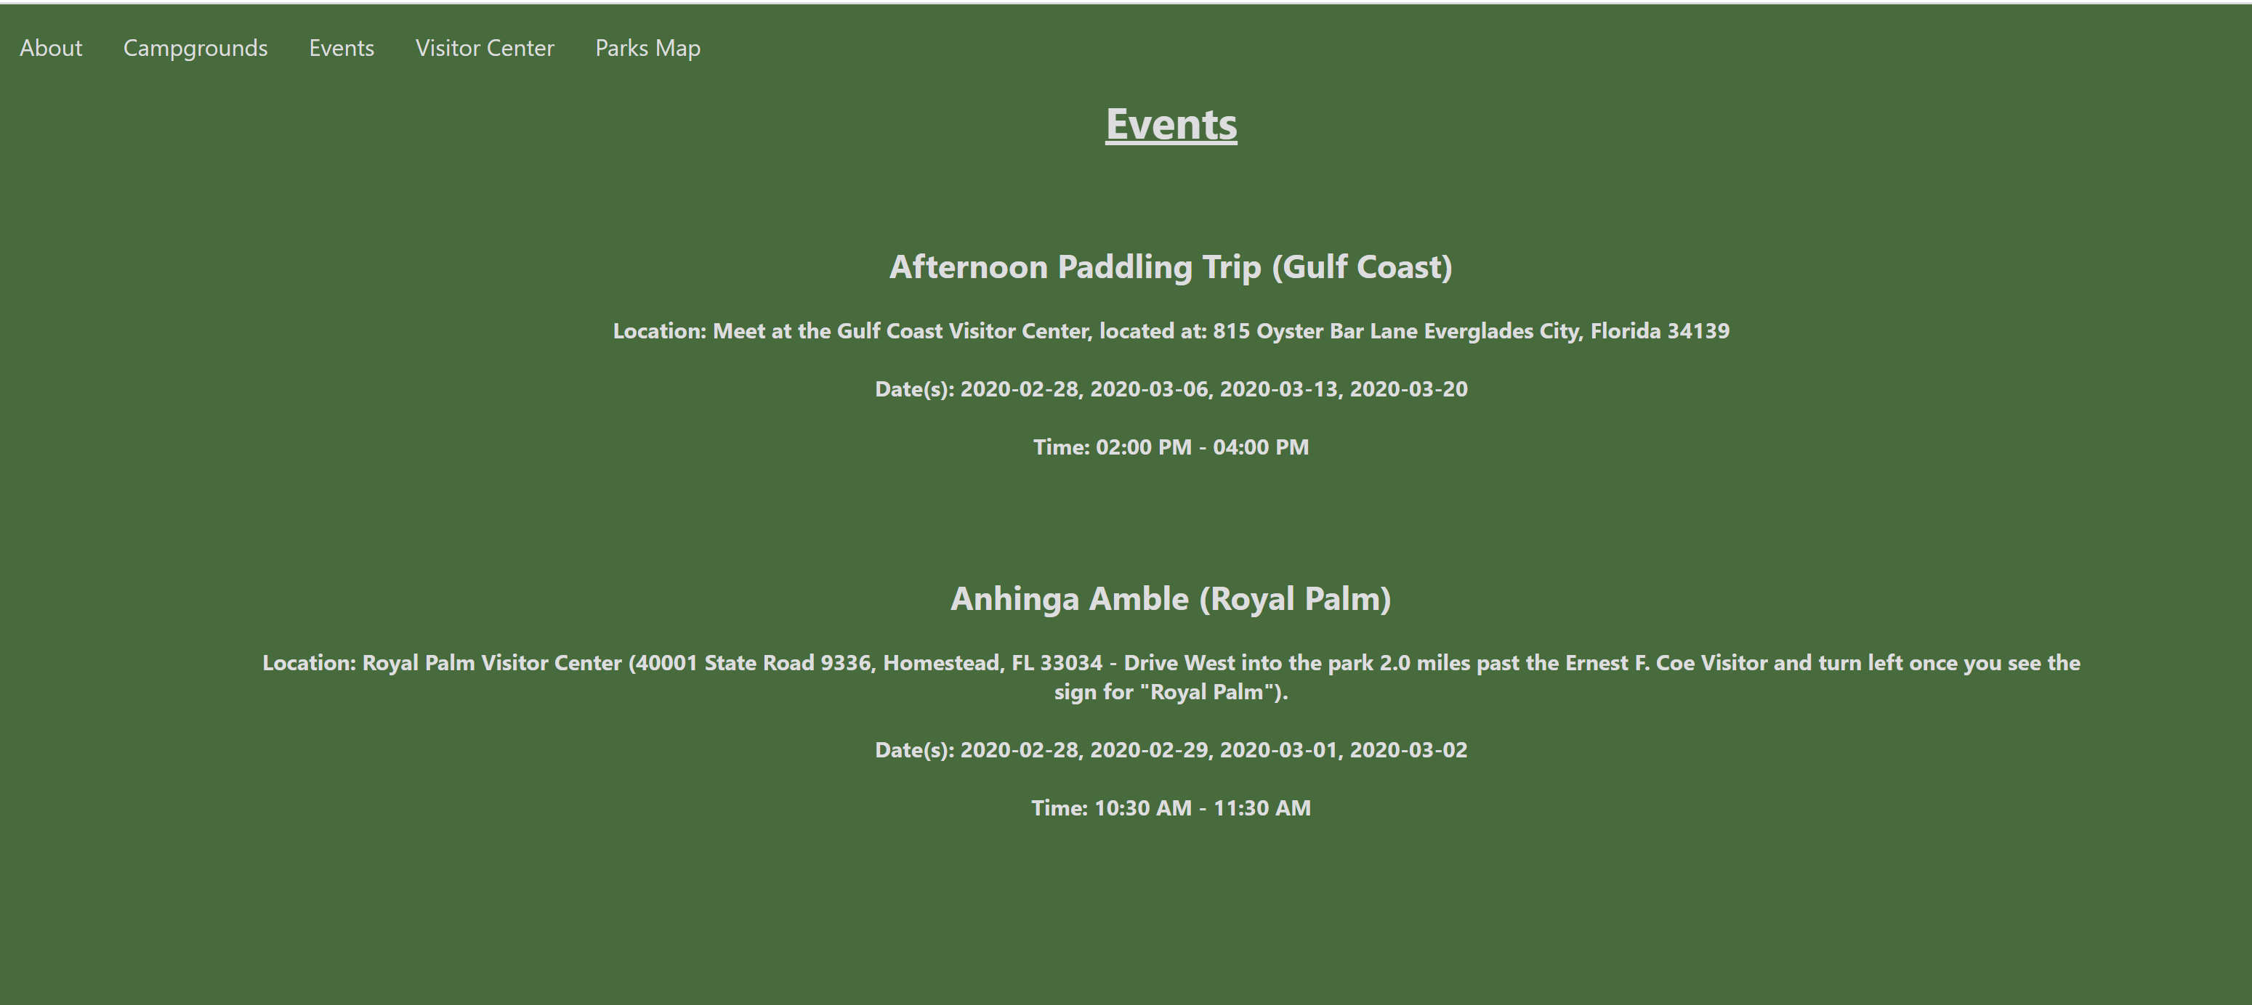

**Visitor Center Page**

The user can select the Visitor Centers tab to learn about the Visitor Centers that are located at that National Park.

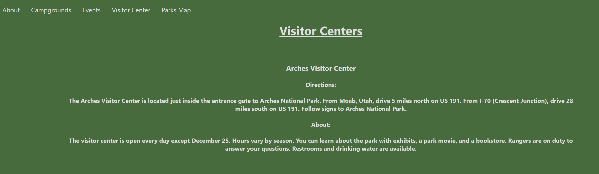

**Parks Map**

When the user selects Parks Map, it returns the user back to the Home Page.

